 **PIDGIN**

**About**

Pidgin is a start-up basically working on the welfare of schools and parents. Our main idea is to solve the problem for parents. The problem we saw that parents were facing was that when they want their ward to get admission in a school they honestly fill form of many different schools from different websites and filling up the same information again and again makes it a bit difficult job. So, to avoid that problem we are here with our Common Admission Form (CAF) which should be filled once by parents and then the form will be circulated in whichever schools they desire.

**Market Demand**

We, after doing a lot of research (Basically taking review from many parents who recently did admission of their ward and asking their point of view), we got to know that the parents are really facing this problem and they are ready to pay/use our service to avoid this problem. We know that parents want the best for their ward, so we are.

We are also working on the welfare of schools which you will be going to know below.

**Relevant Products in the Market**

There are currently many other companies in the market but how we are unique is that:

1. The other companies that high money from schools while our company will provide a free service for schools.
2. On other companies’ website, the parents need to pay huge amount for their admission form while on our website they only need to pay Rs. 30/- form.
3. The most unique point we have is that we would be paying schools 10% extra for each form filled up from our site.
4. Also, the company is started up by college students who have faced the same problem recently, so we understand your problem.
5. Also, the last thing is that the students have a background from Delhi Technological University (DTU) and Bennett University (A Times of India Initiative).

**Target Customers**

Our actual target customers are parents who want their ward to study in a school. The information we would require would be simple like their child name, their name, date of birth, profession, etc.

Basically, we would be requiring the information which schools take from parents while filling up their admission form.

No extra or irrelevant information would be taken up from parents.

Schools are also our target customers as without the support of schools we are nothing to do. The information we would be requiring from schools would be just in which format they want the list of admissions.

It is just as simple as it is.

**Required Knowledge or Expertise**

The things which were required while implementing our startup are:

1. Research: -

It took a lot of time and efforts to look further and without a proper research it was not possible to know the need of people and that our idea could sort the problems faced by people.

We first searched everything on Google so that we could get a clear knowledge about the admission system. We got to know about Directorate of Education (DOE) which governs the education system of schools in Delhi.

Afterwards, we took a clear shot of our rival companies which are currently in the field. We saw their drawbacks, their business model, way of handling/representation and then to check whether we are not following the same.

1. Hardware Required: -

Basically, the only hardware required was only a good working PC and nothing else. On the other way, the user of our product may use PC, smartphone, tablet, and any other thing of that type.

1. Software: -

It required a good knowledge of programming languages like Python, C++, Java, and HTML. We also required the knowledge of App Development which was done in App Studio and moreover the knowledge of Firebase to input the data in our website, app.

Also, we need to get the knowledge about Google Play Store and its policies and other information required to publish our app. Moreover, we need to know how to buy the domain for our website.

**Solution**

The working of our startup can be visualized below for a better understanding: -

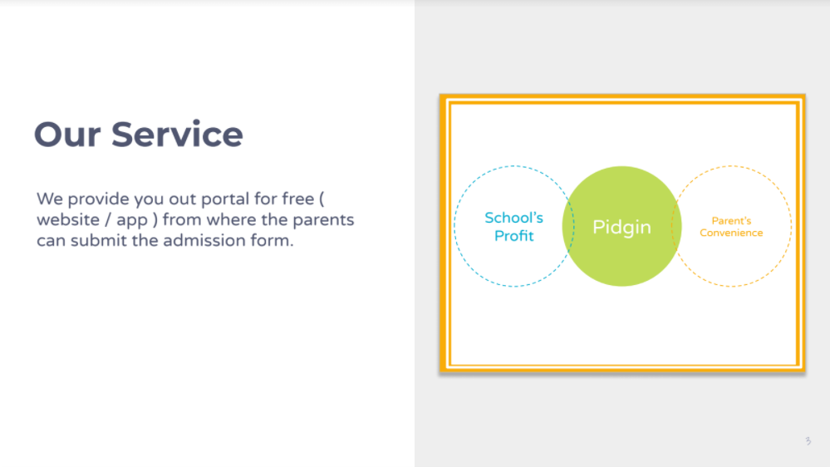

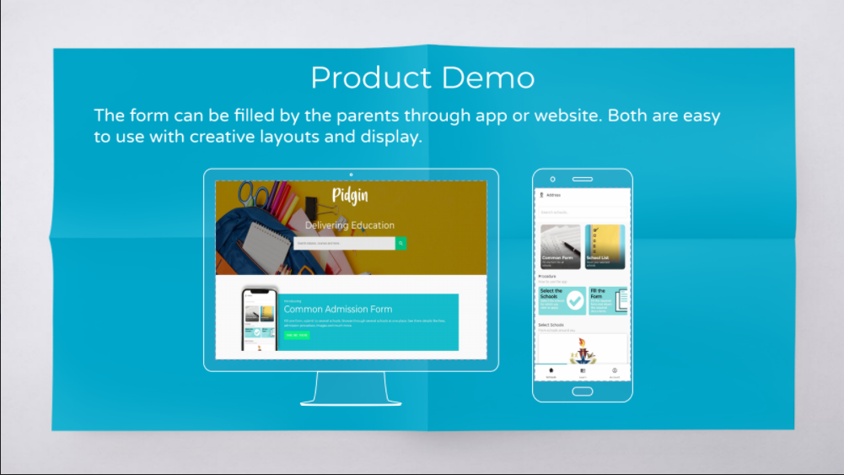

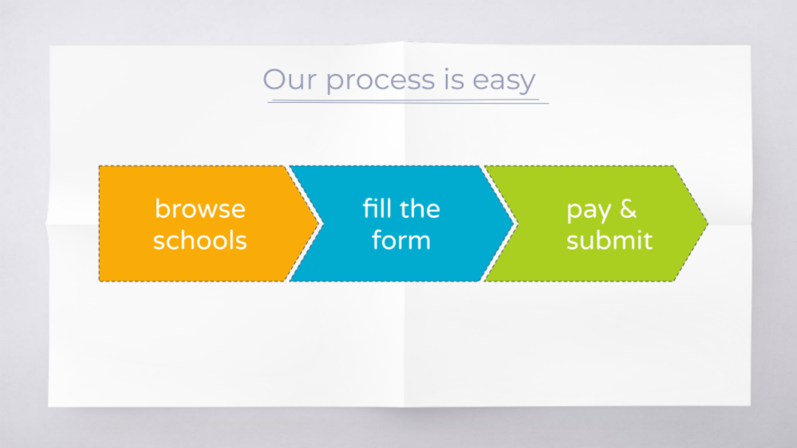

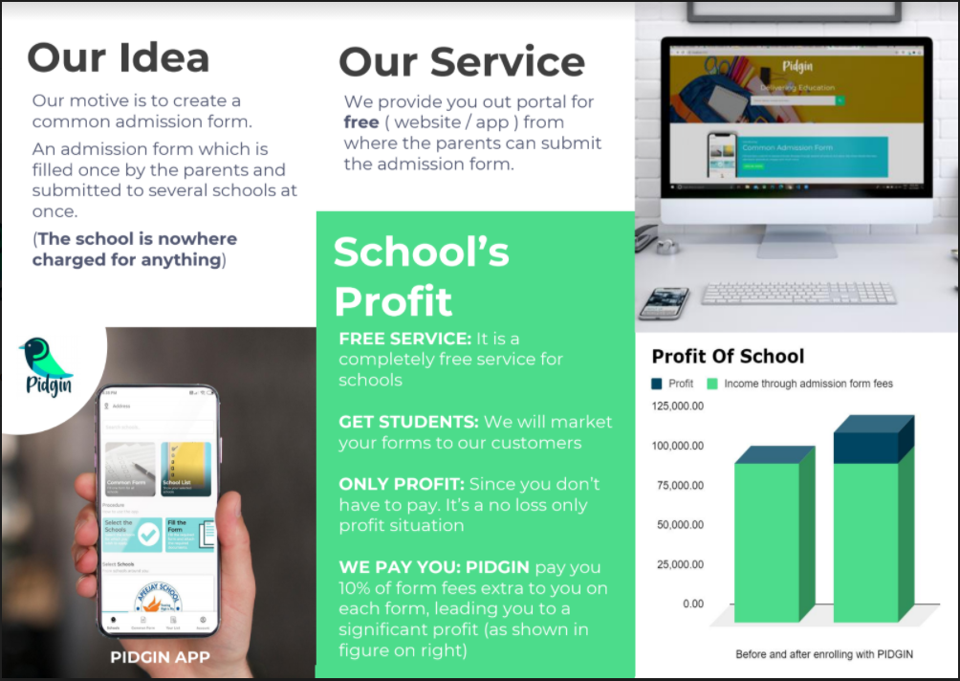

**Estimated Budget**

The budget of our startup is not very expensive. The estimated budget for all things are described below: -

1. For purchasing domain name: $100/year
2. For publishing app on Google Play Store: $25 (One Time Pay)
3. Forming of partnership deed: $10 (One Time Pay)

*All the other things, we were having with us so we didn’t need to buy/spend money on them.

**Marketing Plan**

First of all anything doesn’t go well as you plan for it before. The main problem comes when its time for the marketing for your plan. Basically, from past few months we are trying for the marketing of the plan but nothing is happening. We learnt that whatever our plan is, it need a good marketing strategy.

Due to the Covid-19 we were not able to go to schools for meetings with the principals which was the main thing we are dependent on. We first went directly to the schools receptions and were thrown out. After then we tried to book appointment with school principals by calling at the reception of the schools but the receptionist doesn’t take interest. Moreover, before contacting the schools, we need to make a good pitch for schools so that we could make a good impression on that. After calling up schools we decided to e-mail all schools we know and send them proposal and our business plan but as everyone would know, everyday a lot of e-mails come to schools and so they hardly look them. This demoralized us but we didn’t give up instead we ourselves posted our proposal to schools by giving it at their receptions, this method helped us.

We also created WhatsApp group of students and created account on Facebook and Instagram so that to make people aware. We also did a lot of activities on LinkedIn.

Afterwards, we reached to the companies who make the websites for schools and ask for tie-up with them.

Also, we thought of marketing to parents by the help of our partnered schools.

**Risk Analysis**

Actually there is not a big risk in implementing on this idea as it was quite affordable for us. The only risk we think is that of schools only, as if we don’t have schools with us then we can’t do anything.

Also the main risk is with our studies and future, as we had to miss many of our classes and it disturbs us mentally also as we are not able to concentrate on our studies. It is very hard to keep up both things side-by-side moving on but still we are trying our best to cope up with all.

**Milestone & Timeline**

We want to cover up entire India but for that we are trying to cover up Delhi first. We have not fixed the timeline as we think if this idea didn’t work now, then we would try to implement it next year also and we think we would get success someday and so we would try it for our lifetime till we get success.

*Also check our website https://pidgin.online/